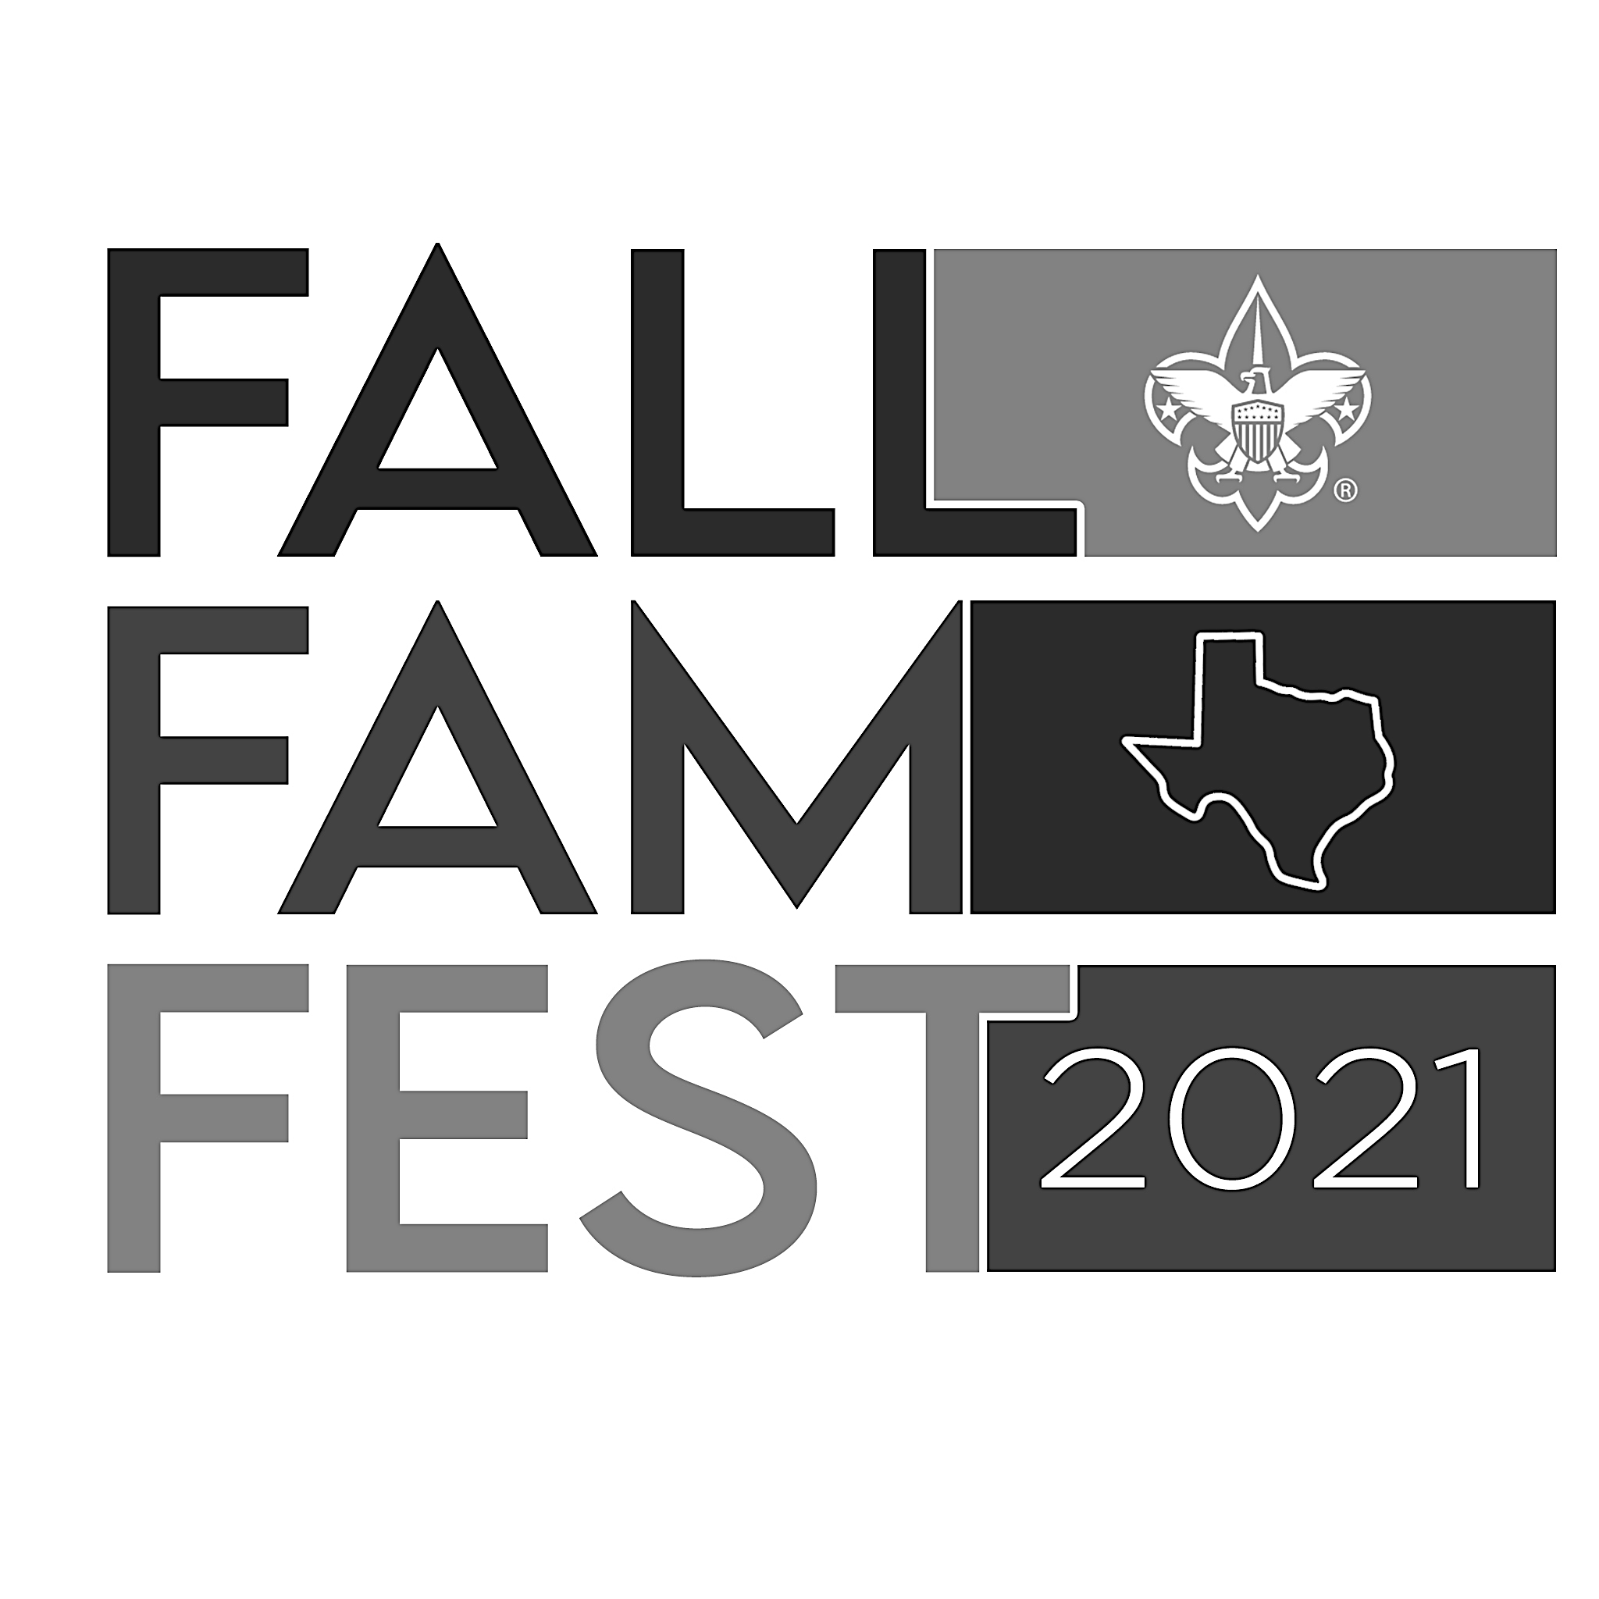LONGHORN COUNCIL FALL FAM FEST
ORION DISTRICT:
“Exploration on the Orion Space Station”

Fall Fam Fest EVENT INFORMATION

Event Location: Huffines Middle School—Lewisville ISD

Event Address: 1440 North Valley Parkway, Lewisville, TX. 75077

Event Dates: Saturday, September 25, 2021

Event Times: 10:00am – 2:00pm

Event Entry Fees: $ 10.00 per Cub Scout Family
*Cub Scout Admission includes one non-scouting friend
Free for Event Volunteers (Scouts/Leaders/Adults)

*Bring a Friend Program: Each cub scout is encouraged to bring a friend to the event

Admission Costs Covers--- BSA Insurance Fee, BSA Event Patch Fee, and Event Supplies Fee
(Activity Items, Prize Items, Logistical Items, etc.)

Each cub scout participant will receive a goodie bag with a Space Station Passport and Space Station Map. The event patches will be awarded during the Orion District Roundtable.

Event Theme: Space Theme---"Exploration on the Orion Space Station”
Orion District Volunteers will set up Activity Stations that would be associated with our Orion Space Station orbiting the Earth in space.

Fall Fam Fest PLANNING/INFORMATION EVENT DATES

Outdoor Events Committee Planning
May/June 2021 Event Committee Meetings

District Committee Proposal-Approval
June/July 2021 District Committee Meeting

Cub Scout Leader Event Information Rollout
July/August Roundtables—Opening Announcements

Cub Scout District Preparation Meeting
September

Event Volunteer Signup for Stations and Positions
Signup Genius for volunteer positions will open once event is approved

Fall Fam Fest COMPONENTS—WE WILL NEED VOLUNTEERS TO HELP!

Set-up Crew (Set up Event Stations) --- MULTIPLE VOLUNTEERS NEEDED

Admission Gate (Take up money, Stamp Hands, Hand out Goodie Bags)—
2 VOLUNTEERS NEEDED

Activity Stations (Run an Activity Station) --- *2 VOLUNTEERS PER STATION NEEDED
*At Least one BSA Scout and one Leader working together would be optimal!

Water/Trash Stations (Replace water and trash bags) --- 1 ATTENDANT NEEDED

Clean-up Crew (Clean up Event Stations) --- MULTIPLE VOLUNTEERS NEEDED

Fall Fam Fest CHALLENGE ACTIVITIES*
Troops/Crews/Packs are asked to provide volunteers to help run each station

Obstacle Course Challenge (Run the Fitness Obstacle Course for a time)
Two Timed Attempts
Kicking Challenge (Kick the soccer ball through the small goals)
4 Balls – Two Attempts
Throwing Challenge (Throw the Softball or Football through the hoops)
4 Balls – 2 Attempts
Fishing Challenge (Fish for plastic bass with spin cast rod/reel combos)
1 Rod/Reel – 6 Casting Attempts
Frisbee Disc Challenge (Toss the Disc to the cage in the least amount throws possible)
1 Disc – 2 Attempts
Bowling Challenge (Roll the Bowling Ball and knock down all the pins in two chances)
1 Ball – 2 Attempts
River Crossing Challenge (Cross the river on carpet stones without falling in)
4 Attempts

Fall Fam Fest SHOOTING RANGES*
*One BSA certified Rangemaster must be on the gun and archery range.
BSA Troops are asked to provide volunteers to help run the ranges

BB Gun Range (Youth one pump BB Guns with Shooting Gallery)
6 shots – 2 Attempts
Archery Range (Youth Longbows and Youth Compound Bows with Archery Targets)
4 Arrows – 2 Attempts

Fall Fam Fest CUB SCOUT ACTIVITIES
Troops/Crews/Packs are asked to provide volunteers to help run each station

Cub Scout Craft Station #1 (Leather Project---Leather Shapes with Chains)
1 Leather Craft Project --- One Round of Instruction/Completion
Cub Scout Craft Station #2 (Wood Projcet--- Jet Fighter Project)
1 Wood Craft Project --- One Round of Instruction/Completion

Fall Fam Fest FUN ZONES
Troops/Crews/Packs are asked to provide volunteers to help run each station

-Face Painting Station (Youth gets face painted by an older BSA Scout)
1 Attempt with Paints
-Photo Op Station (Groups or singles may take pictures with props)
Multiple Attempts with Camera Phones
-Chill Out/First Aid Station (Youth or adults make take a break from the heat or get minor medical attention, if needed) --- NEED A VOLUNTEER WITH MEDICAL TRAINING
Multiple Visits if needed

Fall Fam Fest SCHEDULE OF EVENTS

_____EVENT_______________________TIME FRAME___________________LOCATION______

FRIDAY, SEPT. 24, 2021
*EVENT GATES WILL BE LOCKED AT 10:00PM

Event Set-up (Equipment) 7:00pm – 10:00pm Huffines MS Storage
Facility Track/Field Area

SATURDAY, SEPT. 25, 2021
*EVENT GATES WILL BE OPENED AT 7:00AM

Event Set-up (Stations) 8:00am – 10:00am Huffines MS Track/Field

Activity Stations 10:00am – 2:00pm Track/Field Activity Areas
(Fun Day Hours)

Event Clean-up 2:00pm – 4:00pm Huffines MS Track/Field
Huffines MS Storage

Fall Fam Fest PATCH

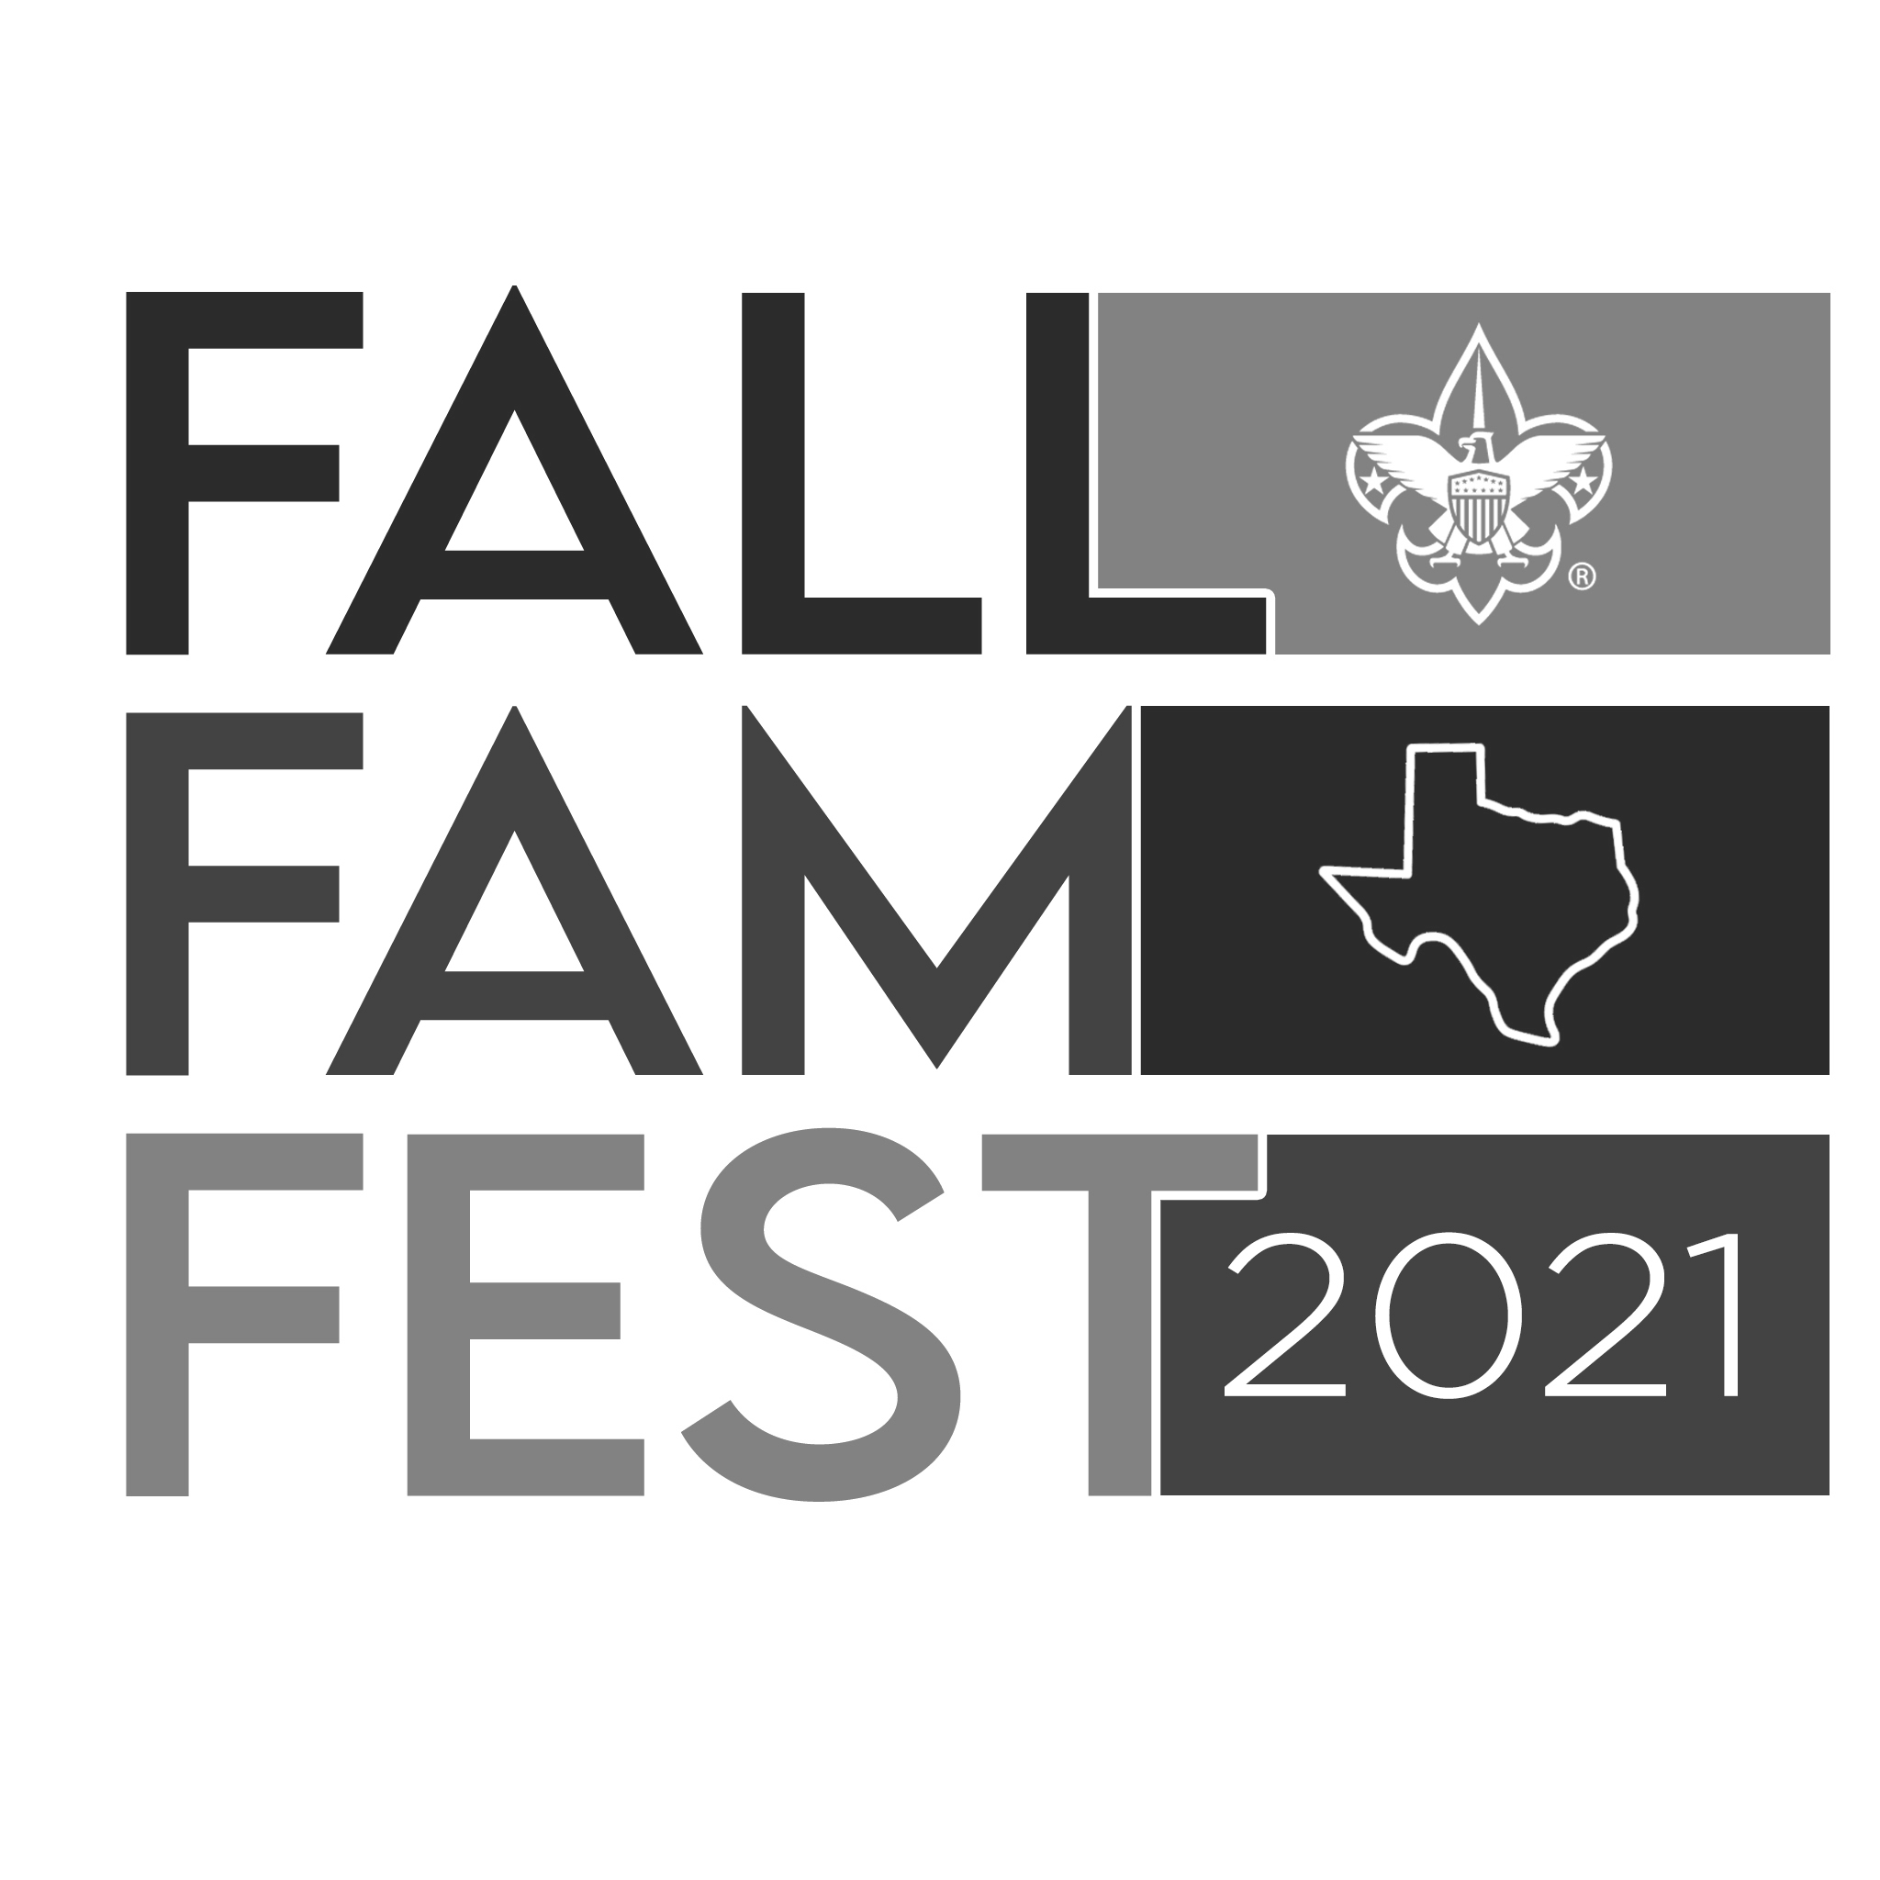

Fall Fam Fest EVENT MAP (ON NEXT PAGE)
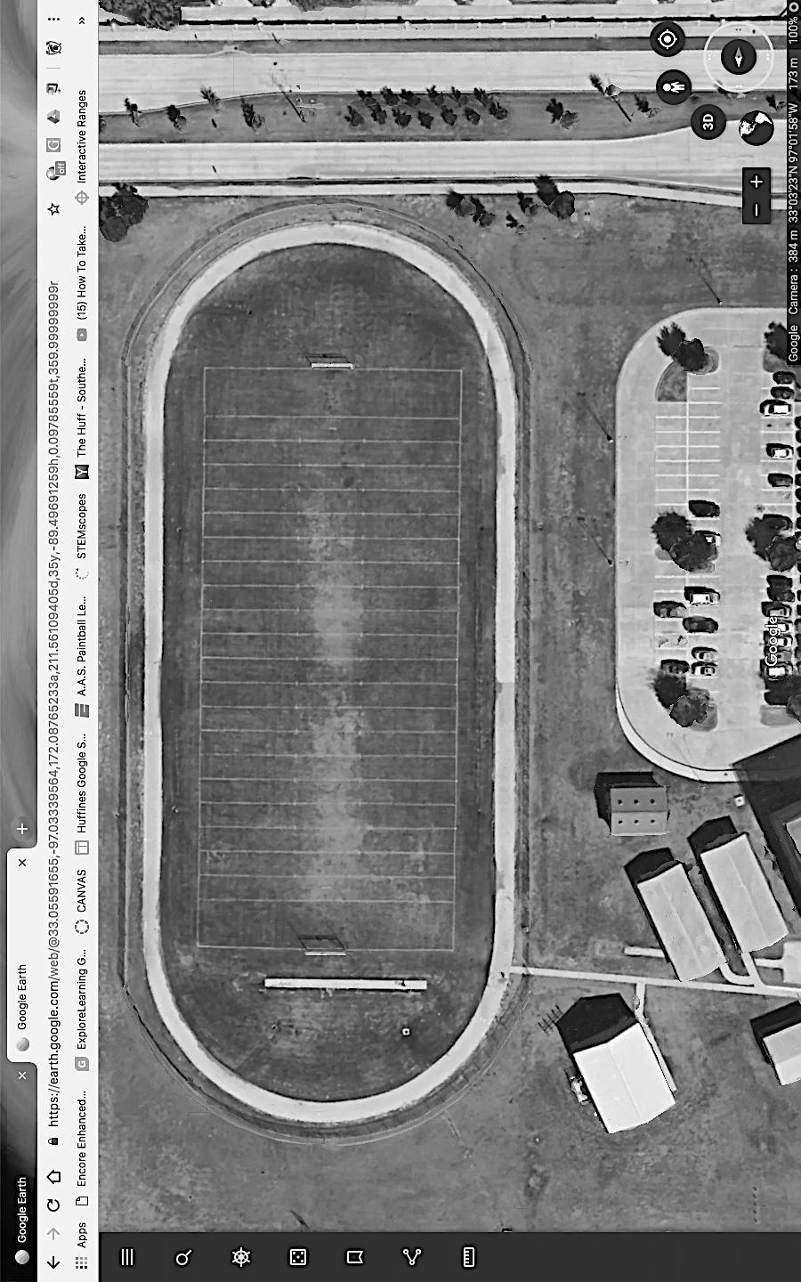
FIRST AID STATION
STORAGE UNIT

SIDE GATE
RR / FIRST AID
OBSTABLE
COURSE

BOWLING
CHALLENGE
THROWING
CHALLENGE
WATER
STAND

WATER
STAND

RESTROOMS IN GYM AREA
BUILDING NOT USED
BUILDING NOT USED
FISHING CHALLENGE
CRAFT STATION #1
CRAFT STATION #2
BB GUN
CHALLENGE
ARCHERY
CHALLENGE
FACE PAINTING
SPACE
PICTURES
RIVER CROSSING CHALLENGE
ADMISSION
STAND

FRISBEE GOLF
CHALLENGE
KICKING
CHALLENGE
MAIN GATE
Entry Point
PARKING LOT
Fall Fam Fest CONTACTS

Orion District Cub Scout Fun Day Event:
Gary Utrup—Orion District Vice Chairperson
garyutrup@gmail.com

Jason Kitchen—Fam Fun Fest Event Coordinator
jtkitchen@verizon.net
972-971-9253

Tony White---Events Committee Co-Chairperson
tonywhite2010@verizon.net

Steve Kral---Events Committee Co-Chairperson
steve.kral@yahoo.com

Chris Young---Outdoor Events Committee Member
fourplackplumes@gmail.com

Marty Rice---Outdoor Events Committee Member
martinrice99@gmail.com

Brea Baygents
Orion District Executive—Longhorn Council
Brea.Baygents@scouting.org

